System \ Dialog \ MessageBox

InputBox

WorkFlow \ FlowChart

Decision

Sequence

WorkFlow \ Control \ If

Message -> Popup box

WriteLine -> writes in output

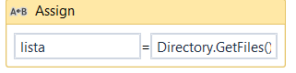

Directory: Delete / GetCurrentDir / SetCurrentDir

A la variable que desee usar agregue “ToString”

* Split
* Replace
* Substring
* Length
* Contains
* Trim
* IndexOf
* ToUpper
* ToLower
* ToInt
* ToString